ROS Installation

(ROS Noetic on Ubuntu 20.04)

Steps:

(1) copy paste the command line and in the terminal wget -c https://raw.githubusercontent.com/qboticslabs/ros_install_noetic/master/ros_install_noetic.sh && chmod +x ./ros_install_noetic.sh && ./ros_install_noetic.sh

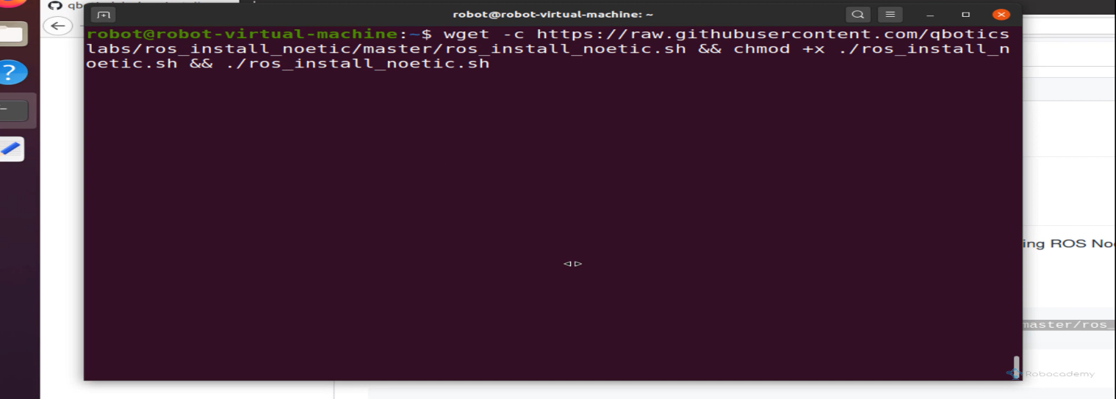

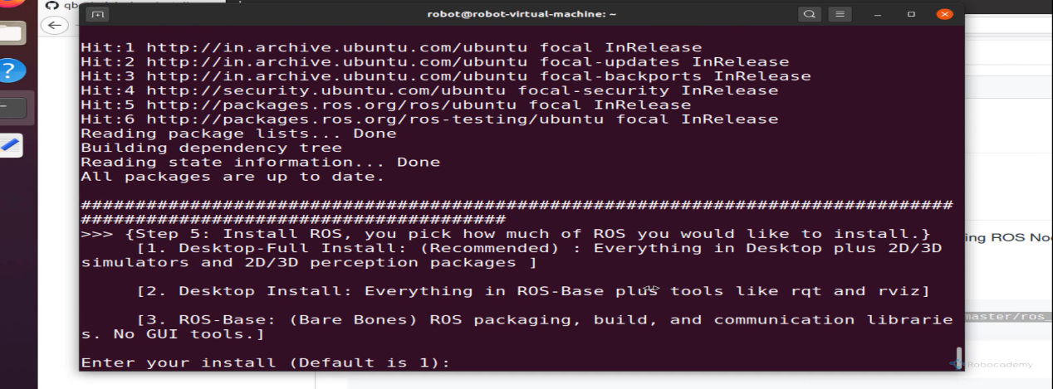 (2) then enter 1 to select default installation

Waite for the installation to complete

(3) After that to test Ros installation write :

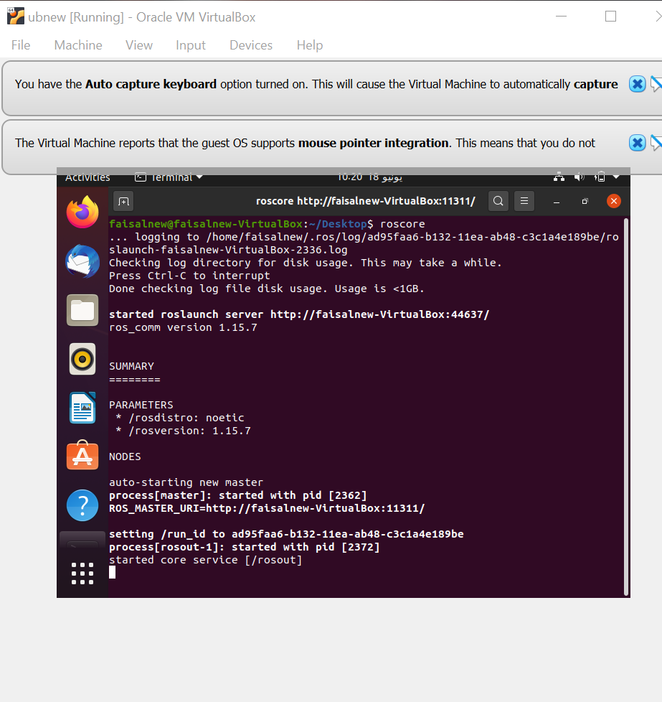(roscore) in the terminal